Git for Windows Installation

Software installation

1. Go to URL: <http://gitforwindows.org/>

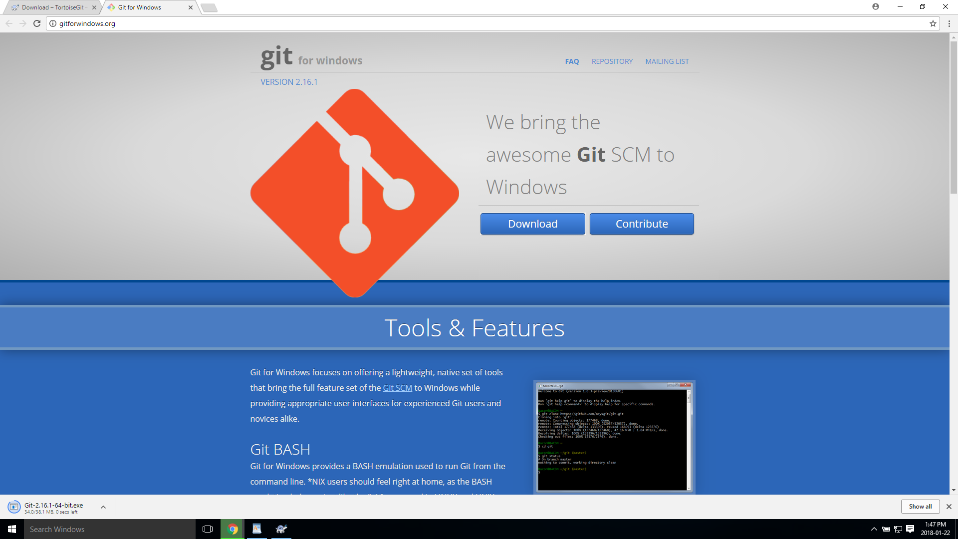

1. Download latest version of Git for Windows for your architecture (64 bit)

<https://github.com/git-for-windows/git/releases/download/v2.16.1.windows.1/Git-2.16.1-64-bit.exe>

1. After downloading run installer executable (Git-2.16.1-64-bit.exe)
2. Use default installation location.

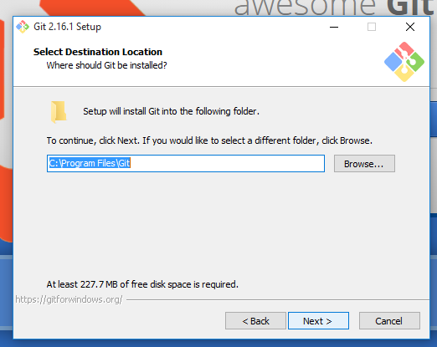

1. Use default components and settings for installation

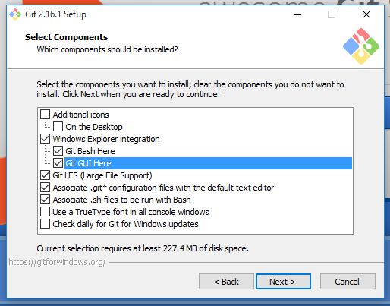

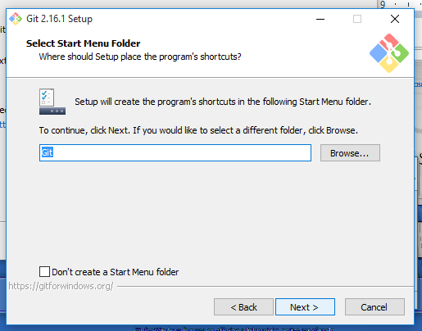

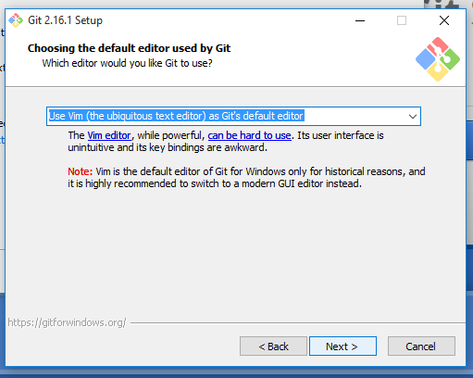

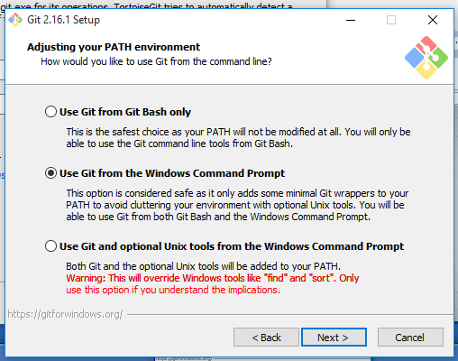

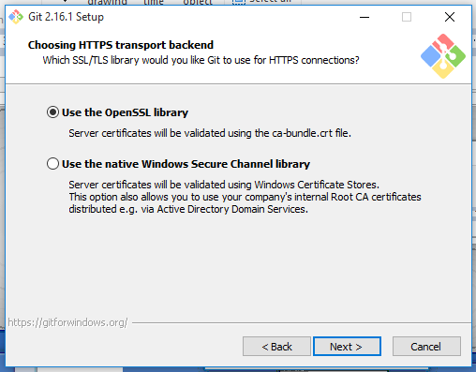

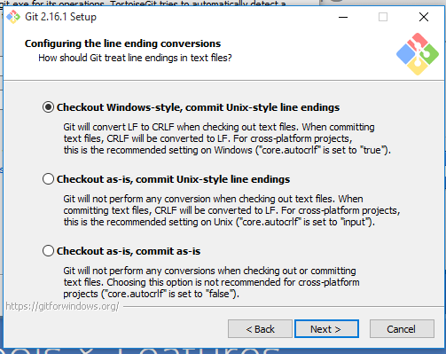

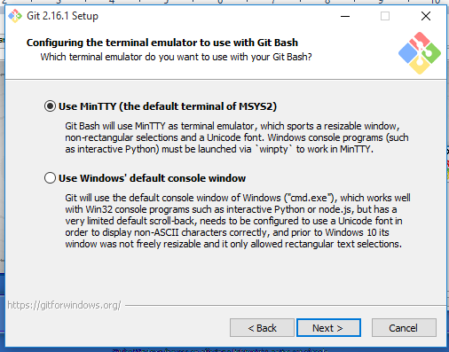

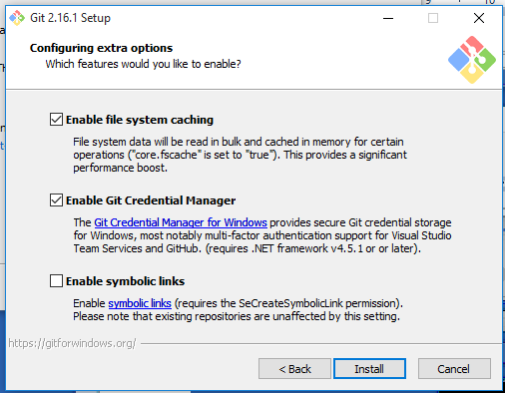

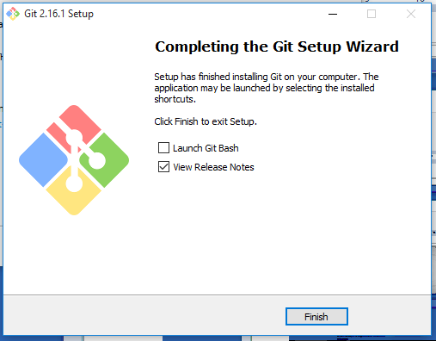

1. Finish your installation.